

| **TITLE : Control Statement** |
| --- |

**AIM:** Create a class myMath. The class contains the following static methods.

i) power (x, y) – to compute x y

ii) fact (x) – to compute x!

Write a program to find the following series.

* ex = 1 +(x/1!)+ (x2/2!) + (x3/3!) + (x4/4!) + … upto n terms (n given by user).
* (1+x)n = 1 +(nx/1!)+ ((n(n-1)x2)/2!) ........ upto n terms (n given by user).

**(Do not make use of inbuilt functions. Use the functions of user defined class MyMath.)**

**_____________________________________________________________________**

**Expected OUTCOME of Experiment:**

**CO2:** Explore arrays, vectors, classes and objects in C++ and Java.

**______________________________________________________________________**

**Books/ Journals/ Websites referred:**

1. E. Balagurusamy , “Programming with Java” McGraw-Hill.
2. Sachin Malhotra, Saurabh Choudhary, “Programming in Java”, Oxford Publications.

**_____________________________________________________________________**

**Pre Lab/ Prior Concepts**

Java basic constructs (like if else statement, control structures, and data types

Programming languages provide various control structures that allow for more complicated execution paths.

A loop statement allows us to execute a statement or group of statements multiple times and following is the general form of a loop statement in most of the programming languages −

| **Sr.No.** | **Loop & Description** |
| --- | --- |
| 1 | [**while loop**](https://www.tutorialspoint.com/java/java_while_loop.htm)  Repeats a statement or group of statements while a given condition is true. It tests the condition before executing the loop body. |
| 2 | [**for loop**](https://www.tutorialspoint.com/java/java_for_loop.htm)  Execute a sequence of statements multiple times and abbreviates the code that manages the loop variable. |
| 3 | [**do...while loop**](https://www.tutorialspoint.com/java/java_do_while_loop.htm)  Like a while statement, except that it tests the condition at the end of the loop body. |

**Loop Control Statements**

Loop control statements change execution from its normal sequence. When execution leaves a scope, all automatic objects that were created in that scope are destroyed.

Java supports the following control statements. Click the following links to check their details.

| **Sr.No.** | **Control Statement & Description** |
| --- | --- |
| 1 | [**break statement**](https://www.tutorialspoint.com/java/java_break_statement.htm)  Terminates the loop or switch statement and transfers execution to the statement immediately following the loop or switch. |
| 2 | [**continue statement**](https://www.tutorialspoint.com/java/java_continue_statement.htm)  Causes the loop to skip the remainder of its body and immediately retest its condition prior to reiterating. |

**Class Diagram:**

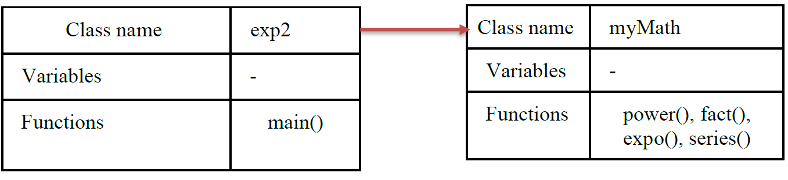

**Algorithm:**

1. Start

2. Print 2^5 power : call power()

3. Print 5 factorial : call fact()

4. Take user input for n and x

5. Print result (1+x)^n : call series()

6. Print e^x result : call expo()

power()

1. Start

2. x and n are parameters

3. Initialize ans = 1

4. Loop n times

a) Ans = ans * x

5. return ans

fact()

1. Start

2. n is a parameter

3. if n>1

• return n * fact(n-1)

4. else return 1.

series()

1. Start

2. x and n are parameters

3. initialize ans = 0

4. loop n+1 times

• ans = ans + (power(x, i) * (fact(n) / fact(n - i))) / fact(i)

5. return ans

expo()

1. Start

2. x and n are parameters

3. initialize ans = 0

4. loop n times

• ans = ans + (power(x, i) / fact(i))

5. return ans

**Implementation details:**

import java.util.*;

import java.lang.Math;

public class Maclaurin_series {

    public static void main(String[] args) {

        Scanner sc = new Scanner(System.in);

        System.out.println("enter value of x for maclaurin");

        int x=sc.nextInt();

        System.out.println("enter value of n");

        int n=sc.nextInt();

        System.out.println("enter value of x for expansion series between 0 and 1 ");

        double y=sc.nextDouble();

        double e = 1, m = 1;

        for (int i = 1; i <= n; i++)

            e += MyMath.power(x, i) / MyMath.fact(i);

        System.out.println("\ne^" + x + " = " + e);

        double r2=Math.exp(x);

        System.out.println("expected e^"+x+"="+r2);

        for (int i = 1; i <= n; i++)

            m += (MyMath.power(y, i) * MyMath.fact(n)) / (MyMath.fact(i) * MyMath.fact(n - i));

        System.out.println("\n(1+" + y + ")^" + n + " = " + m);

        double r1=Math.pow((1+y),n);

        System.out.println("expected (1+"+y+")^"+n+"="+r1);

    }

}

class MyMath {

    public static double power(double x, int y) {

        if (y == 0)

            return 1;

        else

            return power(x, y - 1) * x;

    }

    public static double fact(int x) {

        if (x == 0)

            return 1;

        else

            return fact(x - 1) * x;

    }

}

**Output:**

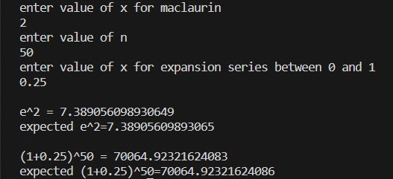

**Conclusion:**

Developed custom math functions in java and implement it using static class concept.

Successfully executed the given problem statement.

**Date: _____________ Signature of faculty in-charge**

**Post Lab Descriptive Questions**

Q.1 Write a program to find the largest of three numbers using the if-else construct.

import java.util.Scanner;

class exp2post {

public static void main(String[] args) {

Scanner sc=new Scanner(System.in);

System.out.println("Enter 3 numbers");

double a=sc.nextDouble();

double b=sc.nextDouble();

double c=sc.nextDouble();

if(a>b){

if(a>c)

System.out.println(a+" is the largest");

else

System.out.println(c+" is the largest");

}

else{

if(b>c)

System.out.println(b+" is the largest");

else

System.out.println(c+" is the largest");

}

}

}

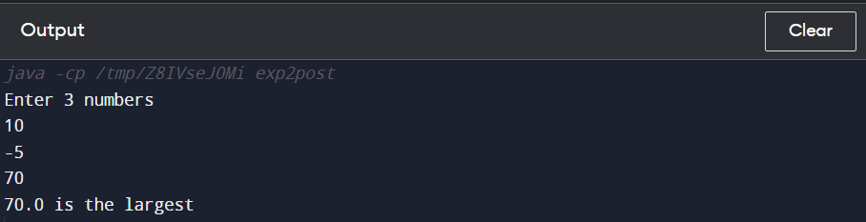

Q.2 Write a program to determine the sum of the following series for a given value of n:

1+½+⅓+....+1/n

import java.util.Scanner;

class ex2post2 {

public static void main(String[] args) {

Scanner sc=new Scanner(System.in);

System.out.print("Enter n: ");

int n=sc.nextInt();

double ans=0;

for(int i=1;i<=n;i++)

ans=ans + 1.0/i;

System.out.println("The answer is: "+ans);

}

}

